Giffnock Consulting
Enterprise Financial Management

Virtual Treasury

IF Importing
Importing goods & materials:
global profit management

Virtual Treasury GPS
Interactive Finance

Giffnock Consulting Pty Ltd
Dr Richard Allan
0412 699 992 v 0110
richard.allan@findiag.com.au

Giffnock Consulting
Interactive Finance

Virtual Treasury
Global Financial GPS

IF Importing Ltd
Global price management case study

Contents

- IF Importing Ltd: business objectives 5
- Contract USD 10 Million import of equipment 6
- Quantifying IF’s opening position 7
- Strategy 1: Remain exposed (no insurance) 8
- Strategy 1: Remain exposed 9
- Strategy 1: Remain exposed 10
- Strategy 1: Remain exposed 12
- Submission to Board/Executive: Core Strategies 14
- Submission to Board/Executive: Alternative Strategies 15
- Submission to Board/Executive: Options 16
- Submission to Board/Executive: Cost/Benefit analysis 17

Giffnock Consulting
Interactive Finance

Global price management
IF Importing Case Study

Virtual Treasury: business objectives
Virtual Treasury provides a strategic management vehicle to assist companies to manage all their price and commodity exposures – in the current case, foreign exchange.
It also ensures companies are aware of business alternatives to financial market-based solutions.
The outcome is either enhanced value or confirmation that the proposed solution is optimal. Virtual Treasury cannot reduce value. It can, however, potentially lead to lower risk and greater awareness of market opportunities.
Virtual Treasury does not in itself speculate, forecast or sell products. It does allow companies to manage expectations of price movements and verify pricing of financial and contractual alternatives
Virtual Treasury does provide proactive management solutions based solely on IF’s business exposures and goals.
IF Importing case study
Three stage methodology
1. Establishing opening position and IF’s goals.
2. Four alternative Strategies for IF Importing
3. Non-financial market Strategies
The final page summarises the case study from the viewpoint of the IF Importing
Giffnock Consulting
Interactive Finance
IF Importing Case Study
The issues
Miner

IF Importing is importing USD 10 million of Importing equipment.
This equipment is due in three months, payable on delivery.
The equipment will have zero value within 6 months and will then require replacement.

Initial issues discussed with IF Importing’s management
 | Issue | Answer | Notes
1 | What is IF’s Value target? | Net Profit | IF’s specified benchmark  (vertical axis)
2 | What is the key Price variable? | AUD/USD | Key variable
3 | What is Net Profit at current prices? | AUD 3 million | Spot value (0.90)
4 | What is amount of the exposure? | USD 10 million | Exposure amount
5 | What is time horizon? | 3 months | Exposure period
6 | Is there an upside target level? | Budgeted Net Profit  $3.3M | Potential Ceiling (profit limit)
7 | Is there a downside risk target? | Retrenchments if profit under $2.6M | Floor (loss limit)
8 | Any repricing clauses or similar contract items? | Don’t know | Check contracts

Note: Issues that will be addressed at a later stage include:
- Does IF want leverage – or, alternatively, a dampening of exposures?
- Do you want to take your views on direction of prices into consideration? Scenario analysis?
- Are there any price levels where there will be a window of opportunity?
- Any levels that represent a specific danger?
Giffnock Consulting
Interactive Finance
IF Importing Case Study
Objective of Interactive Finance

An initial position is identified:
Vertical axis: Net Profit (A$3.0 million)
Horizontal axis: Exchange rate (Spot AUD/USD 0.9000)
Initial position: Net Profit of A$ 3 million at current forward available exchange rate

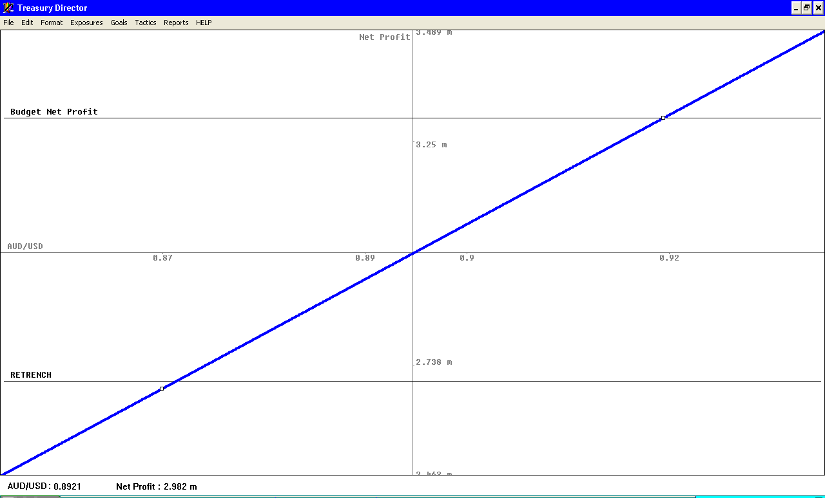
Virtual Treasury

$ Value
Net Profit
USD 10 M Exposure

0.84 0.86 0.88 0.90 0.92 0.94 0.96
AUD/USD

USD 10 M Exposure

Management Overview

1. Net Profit benefits if the Australian Dollar strengthens.
For every one cent rise in the Australian Dollar (e.g. from 0.9000 to 0.9100) Net profit increases by A$ 122,000 or 4%.

2. Retrenchments may occur if Net Profits fall below A$ 2.6 M – or AUD/USD 0.8688

3. Board’s Budgeted Net Profit is A$3.3 M (exchange rate of AUD/USD 0.9250)
Giffnock Consulting
Interactive Finance
Strategy Number 1: Do nothing – remain exposed
In three months IF pay the then current AUD/USD spot exchange rate.
- Unlimited upward profit
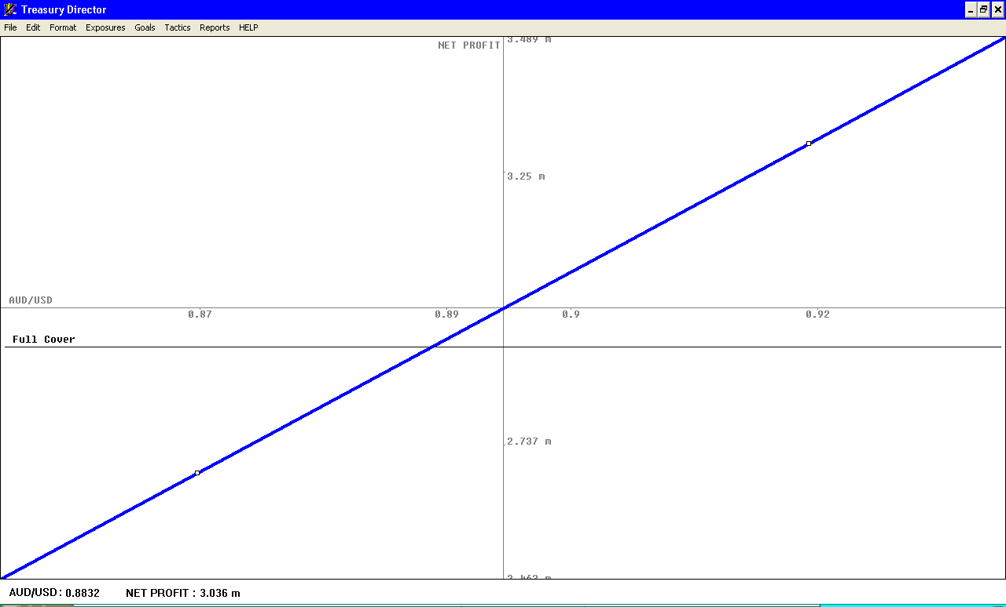
- Unlimited downside risk
Virtual Treasury

Net Profit
USD 10 M Exposure
AUD/USD
Current exchange rate
Full cover
Retrenchment level (not protected)

USD 10 M Exposure

Potential outcomes if USD 10 M exposure left uncovered
Exchange rate | LEAVE UNCOVERED  Exposed to unlimited upside and downside
All cash flows
in June
0.80 | A$1.67M
0.82 | A$1.98M
0.84 | A$2.27M
0.86 | A$2.55M
0.88 | A$2.81M
Current 0.90 | A$3.07M
0.92 | A$3.31M
0.94 | A$3.54M
0.96 | A$3.76M
Giffnock Consulting
Interactive Finance
Strategy Number 2: Full insurance (Full cover)

The exposure is removed by a forward purchase of the US Dollars.

The rate is determined by costs in US and Australian money markets – no forecasting or speculation occurs.

In three months IF pay an additional A$72K and lock in a Net Profit of $2.927 M Ceiling:
Virtual Treasury

Net Profit

USD 10 M Exposure
AUD/USD
100% Cover $2.93 M Profit

USD 10 M Exposure

Management report*
1. Shows that Worst rate (floor) and best rate is a Net Profit of A$ 2.927M*
2. No retrenchments
3. Budget Net Profit shortfall A$ 372K

--------------------------------------------------------------------------------------------------------------
* Based on 3 month rates of 2.73% p.a. in Australia and 0.23% in the USA.
* Spot rate: AUD/USD 0.9000 3 month outright forward rate AUD/USD 0.8947
Giffnock Consulting
Interactive Finance

Strategy Number 3: Protect floor price – no retrenchments
Ceiling & floor levels are added (regardless of cash paid/received)
Ceiling: None
Floor: Retrenchments triggered A$2.6M
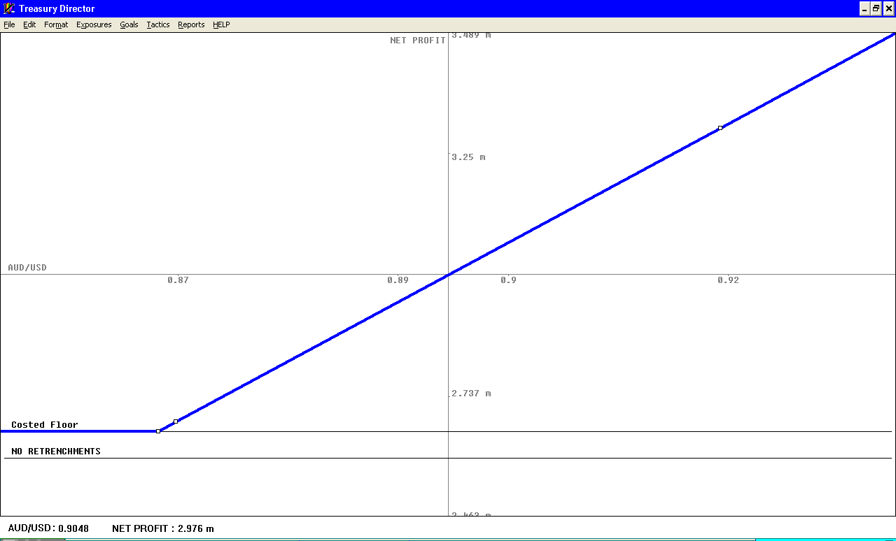
Virtual Treasury

USD 10 M Exposure

AUD/USD

FLOOR

Technical report* Shows that Floor achieved at a cost of A$137K
Virtual Treasury

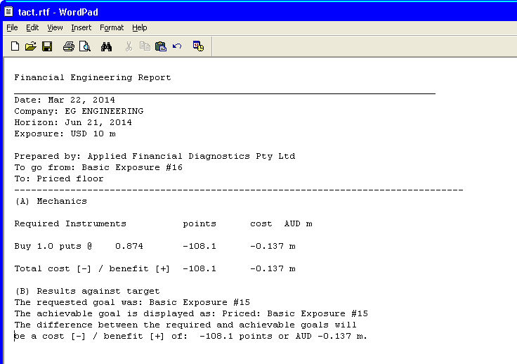
Technical Report: Floor: Objective: No retrenchments (2.6M)
Mechanics: Floor: Total cost A$137K Floor at $2.6M
Giffnock Consulting
Interactive Finance

Protect floor price – no retrenchments (Continued)

Management report* Shows that Floor achieved at Net Profit of A$2.594M

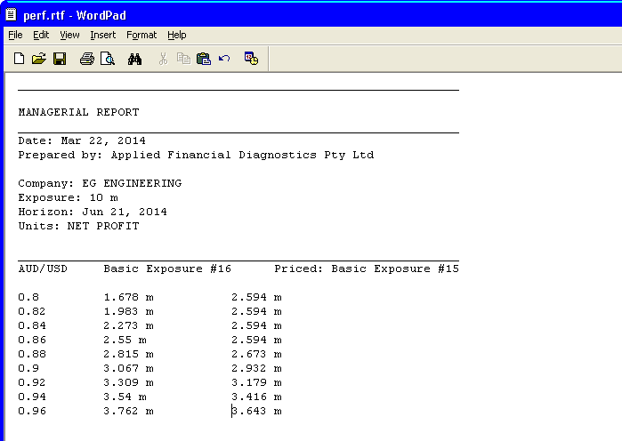
Virtual Treasury

Managerial Report - Floor @ $2.6M: Objective: No retrenchments (2.6M)

FX No cover With Floor

OUTCOMES of three Strategies:
0% cover; 100% cover; Floor at $2.6M
Amount USD 10 Million Date due: June 201x
Exchange rate | LEAVE UNCOVERED  Exposed to unlimited upside and downside | FULL COVER | FLOOR ONLY
 | All cash flows  in June | All cash flows  in June | Initial cost  A$137K
0.80 | A$1.67M | A$2.93M | A$2.59M
0.82 | A$1.98M | A$2.93M | A$2.59M
0.84 | A$2.27M | A$2.93M | A$2.59M
0.86 | A$2.55M | A$2.93M | A$2.59M
0.88 | A$2.81M | A$2.93M | A$2.67M
Current 0.90 | A$3.07M | A$2.93M | A$2.93M
0.92 | A$3.31M | A$2.93M | A$3.18M
0.94 | A$3.54M | A$2.93M | A$3.41M
0.96 | A$3.76M | A$2.93M | A$3.64M

Giffnock Consulting
Interactive Finance
Strategy Number 4: Collar – cashless Floor and Ceiling Profits
Ceiling & floor levels are added (regardless of cash paid/received)
Ceiling: Budgeted Net Profit: A$3.3 M
Floor: Retrenchments triggered A$2.6M
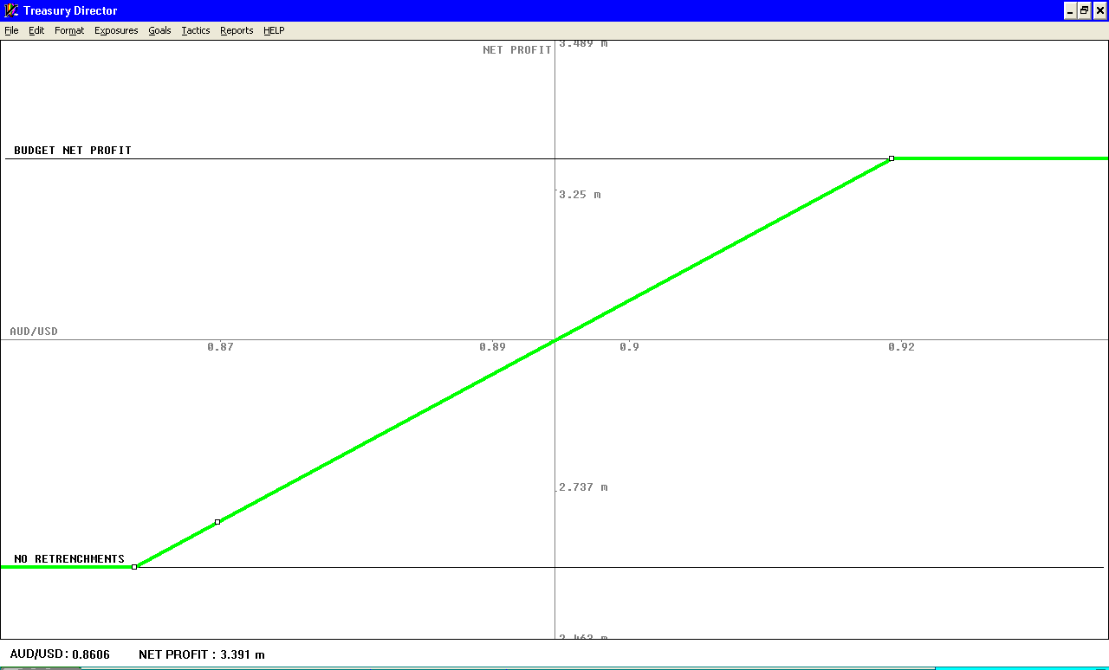
Virtual Treasury

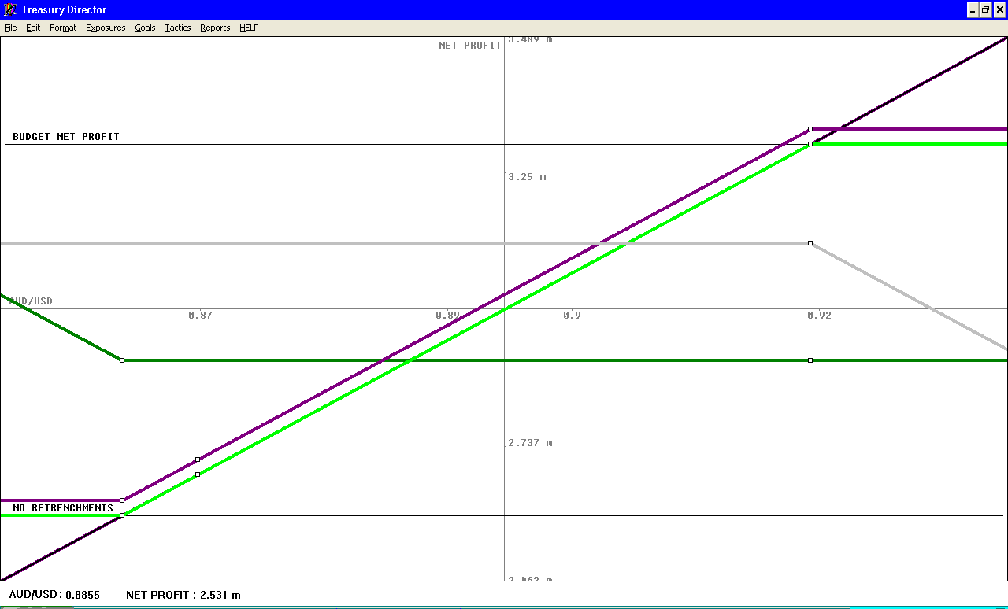
Methodology – showing underlying building of final position
Virtual Treasury

Giffnock Consulting
Interactive Finance
Collar – cashless Floor and Ceiling Profits - continued
Ceiling & floor levels - Final position PRICED
Shows that Worst rate (floor) is a Net Profit of A$ 2.59M
Best rate (ceiling) is a Net profit of A$ 3.61M
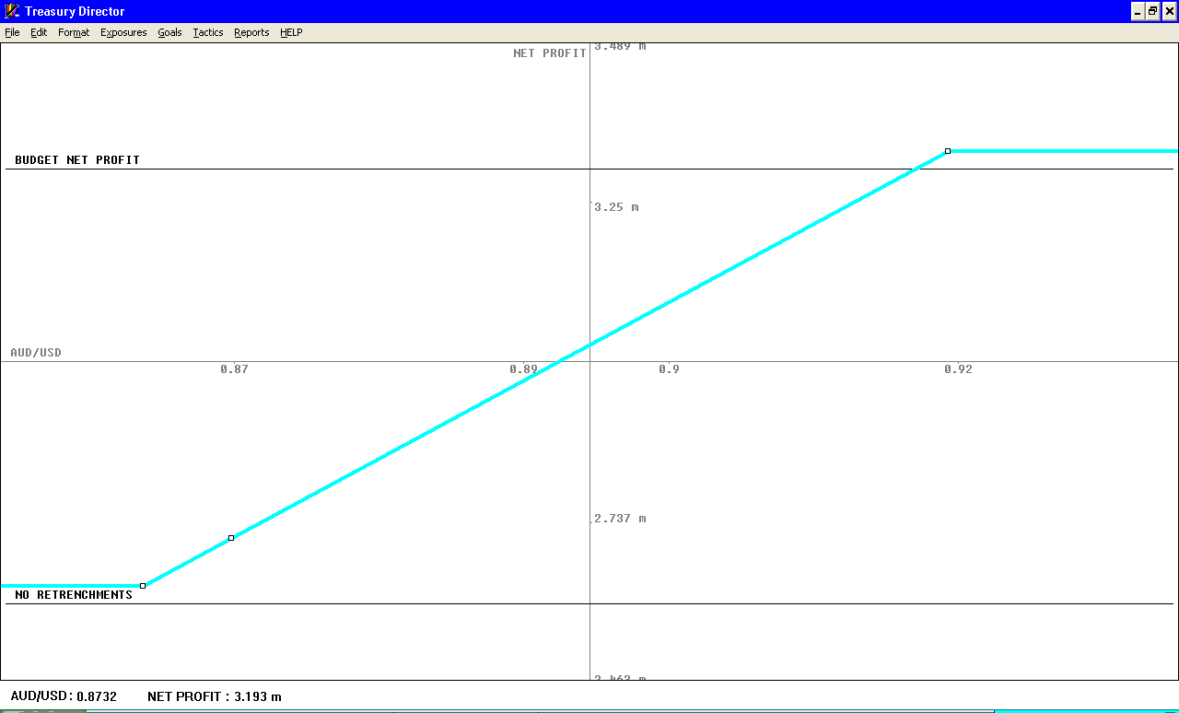
Virtual Treasury

Budgeted Net Profit $2.6M

No Retrenchments $2.6M $2.6M

Exchange rate | LEAVE UNCOVERED  Exposed to unlimited upside and downside | FULL COVER | FLOOR ONLY | COLLAR
 | All cash flows  in June | All cash flows  in June | Initial cost  A$137K | Zero  Cash Cost
0.80 | A$1.67M | A$2.93M | A$2.59M | A$2.59M
0.82 | A$1.98M | A$2.93M | A$2.59M | A$2.59M
0.84 | A$2.27M | A$2.93M | A$2.59M | A$2.59M
0.86 | A$2.55M | A$2.93M | A$2.59M | A$2.59M
0.88 | A$2.81M | A$2.93M | A$2.67M | A$2.67M
0.90 | A$3.07M | A$2.93M | A$2.93M | A$2.93M
0.92 | A$3.31M | A$2.93M | A$3.18M | A$3.18M
0.94 | A$3.54M | A$2.93M | A$3.41M | A$3.61M
0.96 | A$3.76M | A$2.93M | A$3.64M | A$3.61M

Giffnock Consulting
Interactive Finance
Final Board Strategy Report
Equipment cost management Strategy
Key trigger levels
Net Profit A$ 3.3M
Retrenchments A$ 2.6 M
Global Prices: Opportunity & risk levels
201w– 201x

NET PROFIT

May 1w July 1w Sept 1w Nov 1w Jan 1w Mar 1x 14
RETRENCH
Global Prices: Opportunity & risk levels
5 years
201t 201u 201v 201w 201x
RETRENCH
NET PROFIT
Giffnock Consulting
Interactive Finance
Alternative Strategies

Contract alternatives
1. Price in Australian Dollars
Current US Dollar cost: USD 10 million (= A$ 11,200,000 fully covered))
Any Australian dollar price UNDER this price (such as spot rate at AUD/USD 0.90 = AUD 11,111,111) would add to Net Profit.

2. Insert repricing clause, sharing benefits and costs of exchange rate movement equally
sharing of 50:50 movement from current spot would save A$36 K
plus get 50% of all upside.

Watching Briefs

3. Replacement Machine
Due to be replaced in November 201x.
Current forward (A$ locked in) rate: US$ 10 M = A$ 11.25M
This would reduce Net profit margin from $3 M to $2.86 M
Notify if either upside or downside triggers breached.

3. New Global Financial Crisis
Major Balance Sheet opportunities due to commercial pressures offshore and onshore.
Example: outright cost not only of machinery but of equity in competitors &/or suppliers.

Giffnock Consulting
Interactive Finance
Further adjustments can be made at will

Green line: IF Importing now want to simply protect against retrenchments and benefit from any strengthening of the Australian Dollar

Blue line: IF Importing “high risk/high return” Strategy – although protecting floor to ensure no retrenchments,
benefit from any weakening of the Australian Dollar

Virtual Treasury

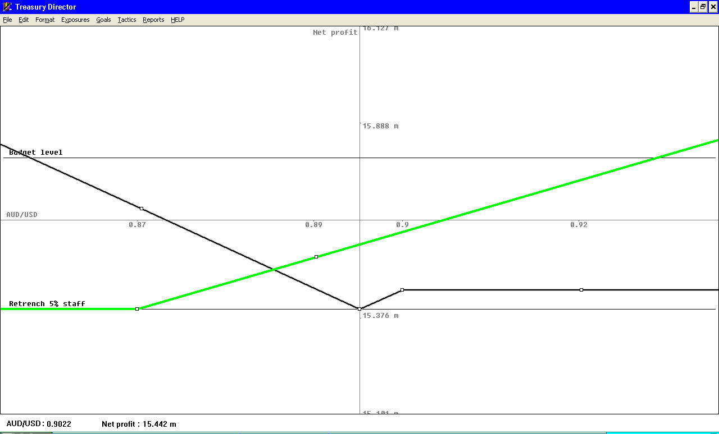
Strategy to benefit from stronger A$
Strategy to benefit from weakening A$

IF Importing can change their Pay-off profile as required

Giffnock Consulting
Interactive Finance
Cost/Benefit review: IF’s perspective

1. Transparency

Benchmarks and solutions are all based on IF’s commercial issues and targets, not financial instruments or terminology

2. Profit and value enhancement

Method involves identifying a range of potential solutions, including commercial, contractual and financial market-based options. Also identification of Windows of Opportunity

3. ‘Bankability’ - creditworthiness

Financial institutions may increase limits/reduce margins because they are aware IF Importing has a clear Strategy based on a quantified set of alternatives

4. Reduced margins & fees

Financial institutions are also aware IF can independently price potential solutions – so likelihood of excess margins should be reduced

5. Absence of forecasting or scenario management in initial review

IFs management of expectations or scenario analysis of exchange rate movements is not introduced until after core analysis
Decisions based on expectations would be made by IF Importing.

Implications

Both IF Importing and their financial service providers benefit from the analysis – regardless of which route is taken and whether further benefits occur during the journey.

Dr Richard Allan
0412 699 992
Richard.allan@findiag.com.au
© Giffnock Consulting 2016

